LAB # 2: MS ACCESS (Queries and Reports)
Objective:
1-Introduction to MS ACCESS 2-How to create tables.
3-How to create queries, reports, and forms.
Scope:
The student should know the following:
- MS Access basics.
- MS Access Practice.
- Basic exercises.

Useful Concepts:
Table name, its column name and column’s datatypes. How to create queries on tables.
Forms and Reports.
Discussion:
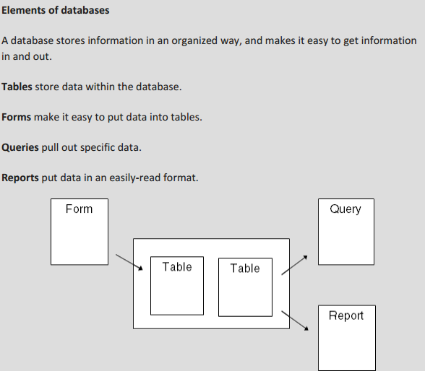
Queries, Reports, Importing External Data into Access.

Importing External Data

Through External Data option on the main ribbon you can follow the GUI instructions to import the data from different data sources, like from a data file (csv, xlxs, text file), from different databases (Access, SQL server, Azure) and from online sources. 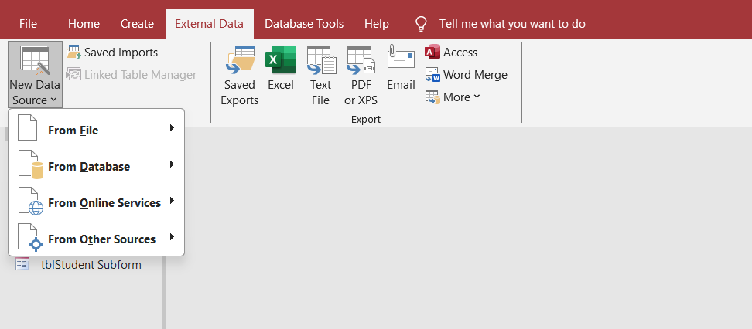

Queries
A query is a request for data results, and for action on data. You can use a query to answer a simple question, to perform calculations, to combine data from different tables, or even to add, change, or delete table data.

Create Select Query
If you want to review data from only certain fields in a table, or review data from multiple tables simultaneously or maybe just see the databased on certain criteria, you can use the Select query. Let us now look into a simple example in which we will create a simple query which will retrieve information from tblEmployees table. Open the database and click on the Create tab.
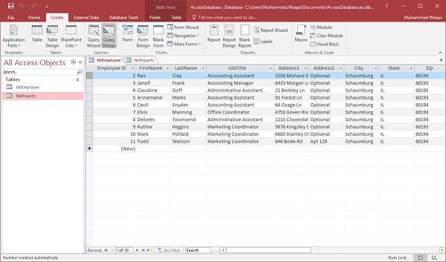
Click Query Design.
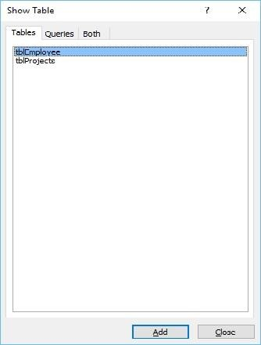
In the Tables tab, on the Show Table dialog, double-click the tblEmployees table and then Close the dialog box.

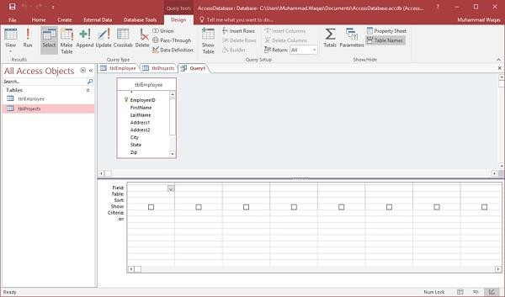
In the tblEmployees table, double-click all those fields which you want to use for the query. Add these fields to the query design grid as shown in the following screenshot.
You can check mark the fields you want to show in the final result under the Show: section. You can also sort the result of the said query by assigning a field ASCENDING or DESCENDING order in the Sort: section of the fields. The field first will sort first and then the second field would sort according to its order.
You can also set criteria on fields to get the data according to your specific needs. Below are the list of commands you can make in this section.

Criteria for Text, Memo and Hyper Links:
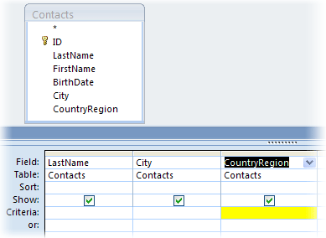
To include records that... | Use this criterion | Query result
Exactly match a value, such as China | "China" | Returns records where the Country/Region field is set to China.
Do not match a value, such as Mexico | Not "Mexico" | Returns records where the Country/Region field is set to a country/region other than Mexico.
Begin with the specified string, such as U | Like U* | Returns records for all countries/regions whose names start with "U", such as UK, USA, and so on.
Do not begin with the specified string, such as U | Not Like U* | Returns records for all countries/regions whose names start with a character other than "U".
Contain the specified string, such as Korea | Like "*Korea*" | Returns records for all countries/regions that contain the string "Korea".
Do not contain the specified string, such as Korea | Not Like "*Korea*" | Returns records for all countries/regions that do not contain the string "Korea".
End with the specified string, such as "ina" | Like "*ina" | Returns records for all countries/regions whose names end in "ina", such as China and Argentina.
Do not end with the specified string, such as "ina" | Not Like "*ina" | Returns records for all countries/regions that do not end in "ina", such as China and Argentina.
Contain null (or missing) values | Is Null | Returns records where there is no value in the field.
Do not contain null values | Is Not Null | Returns records where the value is not missing in the field.
Contain zero-length strings | "" (a pair of quotes) | Returns records where the field is set to a blank (but not null) value. For example, records of sales made to another department might contain a blank value in the Country/Region field.
Do not contain zero-length strings | Not "" | Returns records where the Country/Region field has a nonblank value.
Contains null values or zero-length strings | "" Or Is Null | Returns records where there is either no value in the field, or the field is set to a blank value.
Is not empty or blank | Is Not Null And Not "" | Returns records where the Country/Region field has a nonblank, non-null value.
Follow a value, such as Mexico, when sorted in alphabetical order | >= "Mexico" | Returns records of all countries/regions, beginning with Mexico and continuing through the end of the alphabet.
Fall within a specific range, such as A through D | Like "[A-D]*" | Returns records for countries/regions whose names start with the letters "A" through "D".
Match one of two values, such as USA or UK | "USA" Or "UK" | Returns records for USA and UK.
Contain one of the values in a list of values | In("France", "China", "Germany", "Japan") | Returns records for all countries/regions specified in the list.
Contain certain characters at a specific position in the field value | Right([CountryRegion], 1) = "y" | Returns records for all countries/regions where the last letter is "y".
Satisfy length requirements | Len([CountryRegion]) > 10 | Returns records for countries/regions whose name is more than 10 characters long.
Match a specific pattern | Like "Chi??" | Returns records for countries/regions, such as China and Chile, whose names are five characters long and the first three characters are "Chi".

Criteria for numerical Fields:
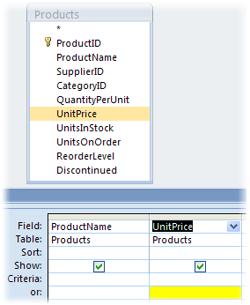
To include records that... | Use this criterion | Query Result
Exactly match a value, such as 100 | 100 | Returns records where the unit price of the product is $100.
Do not match a value, such as 1000 | Not 1000 | Returns records where the unit price of the product is not $1000.
Contain a value smaller than a value, such as 100 | < 100  <= 100 | Returns records where the unit price is less than $100 (<100). The second expression (<=100) displays records where the unit price is less than or equal to $100.
Contain a value larger than a value, such as 99.99 | >99.99  >=99.99 | Returns records where the unit price is greater than $99.99 (>99.99). The second expression displays records where the unit price is greater than or equal to $99.99.
Contain one of the two values, such as 20 or 25 | 20 or 25 | Returns records where the unit price is either $20 or $25.
Contain a value that falls with a range of values | >49.99 and <99.99  -or-  Between 50 and 100 | Returns records where the unit price is between (but not including) $49.99 and $99.99.
Contain a value that falls outside a range | <50 or >100 | Returns records where the unit price is not between $50 and $100.
Contain one of many specific values | In(20, 25, 30) | Returns records where the unit price is either $20, $25, or $30.
Contain a value that ends with the specified digits | Like "*4.99" | Returns records where the unit price ends with "4.99", such as $4.99, $14.99, $24.99, and so on.
Contain null null (or missing) values | Is Null | Returns records where no value is entered in the Unit/Price field.
Contain non-null values | Is Not Null | Returns records where the value is not missing in the Unit/Price field.

Criteria for Date/Time Fields:
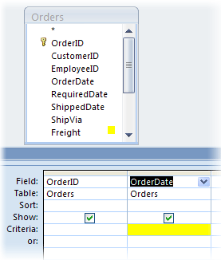
To include records that ... | Use this criterion | Query result
Exactly match a value, such as 2/2/2006 | #2/2/2006# | Returns records of transactions that took place on Feb 2, 2006. Remember to surround date values with the # character so that Access can distinguish between date values and text strings.
Do not match a value, such as 2/2/2006 | Not #2/2/2006# | Returns records of transactions that took place on a day other than Feb 2, 2006.
Contain values that fall before a certain date, such as 2/2/2006 | < #2/2/2006# | Returns records of transactions that took place before Feb 2, 2006.  To view transactions that took place on or before this date, use the <= operator instead of the < operator.
Contain values that fall after a certain date, such as 2/2/2006 | > #2/2/2006# | Returns records of transactions that took place after Feb 2, 2006.  To view transactions that took place on or after this date, use the >= operator instead of the > operator.
Contain values that fall within a date range | >#2/2/2006# and <#2/4/2006# | Returns records where the transactions took place between Feb 2, 2006 and Feb 4, 2006.  You can also use the Between operator to filter for a range of values, including the end points. For example, Between #2/2/2006# and #2/4/2006# is the same as >=#2/2/2006# and <=#2/4/2006# .
Contain values that fall outside a range | <#2/2/2006# or >#2/4/2006# | Returns records where the transactions took place before Feb 2, 2006 or after Feb 4, 2006.
Contain one of two values, such as 2/2/2006 or 2/3/2006 | #2/2/2006# or #2/3/2006# | Returns records of transactions that took place on either Feb 2, 2006 or Feb 3, 2006.
Contain one of many values | In (#2/1/2006#, #3/1/2006#, #4/1/2006#) | Returns records where the transactions took place on Feb 1, 2006, March 1, 2006, or April 1, 2006.
Contain a date that falls in a specific month (irrespective of year), such as December | DatePart("m", [SalesDate]) = 12 | Returns records where the transactions took place in December of any year.
Contain a date that falls in a specific quarter (irrespective of year), such as the first quarter | DatePart("q", [SalesDate]) = 1 | Returns records where the transactions took place in the first quarter of any year.
Contain today's date | Date() | Returns records of transactions that took place on the current day. If today's date is 2/2/2006, you see records where the Order/Date field is set to Feb 2, 2006.
Contain yesterday's date | Date()-1 | Returns records of transactions that took place the day before the current day. If today's date is 2/2/2006, you see records for Feb 1, 2006.
Contain tomorrow's date | Date() + 1 | Returns records of transactions that took place the day after the current day. If today's date is 2/2/2006, you see records for Feb 3, 2006.
Contain dates that fall during the current week | DatePart("ww", [SalesDate]) = DatePart("ww", Date()) and Year( [SalesDate]) = Year(Date()) | Returns records of transactions that took place during the current week. A week starts on Sunday and ends on Saturday.
Contain dates that fell during the previous week | Year([SalesDate])* 53 + DatePart("ww", [SalesDate]) = Year(Date())* 53 + DatePart("ww", Date()) - 1 | Returns records of transactions that took place during the last week. A week starts on Sunday and ends on Saturday.
Contain dates that fall during the following week | Year([SalesDate])* 53+DatePart("ww", [SalesDate]) = Year(Date())* 53+DatePart("ww", Date()) + 1 | Returns records of transactions that will take place next week. A week starts on Sunday and ends on Saturday.
Contain a date that fell during the last 7 days | Between Date() and Date()-6 | Returns records of transactions that took place during the last 7 days. If today's date is 2/2/2006, you see records for the period Jan 24, 2006 through Feb 2, 2006.
Contain a date that belongs to the current month | Year([SalesDate]) = Year(Now()) And Month([SalesDate]) = Month(Now()) | Returns records for the current month. If today's date is 2/2/2006, you see records for Feb 2006.
Contain a date that belongs to the previous month | Year([SalesDate])* 12 + DatePart("m", [SalesDate]) = Year(Date())* 12 + DatePart("m", Date()) - 1 | Returns records for the previous month. If today's date is 2/2/2006, you see records for Jan 2006.
Contain a date that belongs to the next month | Year([SalesDate])* 12 + DatePart("m", [SalesDate]) = Year(Date())* 12 + DatePart("m", Date()) + 1 | Returns records for the next month. If today's date is 2/2/2006, you see records for Mar 2006.
Contain a date that fell during the last 30 or 31 days | Between Date( ) And DateAdd("M", -1, Date( )) | A month's worth of sales records. If today's date is 2/2/2006, you see records for the period Jan 2, 2006. to Feb 2, 2006
Contain a date that belongs to the current quarter | Year([SalesDate]) = Year(Now()) And DatePart("q", Date()) = DatePart("q", Now()) | Returns records for the current quarter. If today's date is 2/2/2006, you see records for the first quarter of 2006.
Contain a date that belongs to the previous quarter | Year([SalesDate])*4+DatePart("q",[SalesDate]) = Year(Date())*4+DatePart("q",Date())- 1 | Returns records for the previous quarter. If today's date is 2/2/2006, you see records for the last quarter of 2005.
Contain a date that belongs to the next quarter | Year([SalesDate])*4+DatePart("q",[SalesDate]) = Year(Date())*4+DatePart("q",Date())+1 | Returns records for the next quarter. If today's date is 2/2/2006, you see records for the second quarter of 2006.
Contain a date that falls during the current year | Year([SalesDate]) = Year(Date()) | Returns records for the current year. If today's date is 2/2/2006, you see records for the year 2006.
Contain a date that belongs to the previous year | Year([SalesDate]) = Year(Date()) - 1 | Returns records of transactions that took place during the previous year. If today's date is 2/2/2006, you see records for the year 2005.
Contain a date that belongs to next year | Year([SalesDate]) = Year(Date()) + 1 | Returns records of transactions with next year's date. If today's date is 2/2/2006, you see records for the year 2007.
Contain a date that falls between Jan 1 and today (year to date records) | Year([SalesDate]) = Year(Date()) and Month([SalesDate]) <= Month(Date()) and Day([SalesDate]) <= Day (Date()) | Returns records of transactions with dates that fall between Jan 1 of the current year and today. If today's date is 2/2/2006, you see records for the period Jan 1, 2006 to 2/2/2006.
Contain a date that occurred in the past | < Date() | Returns records of transactions that took place before today.
Contain a date that occurrs in the future | > Date() | Returns records of transactions that will take place after today.
Filter for null (or missing) values | Is Null | Returns records where the date of transaction is missing.
Filter for non-null values | Is Not Null | Returns records where the date of transaction is known.

Criteria for Yes/No Fields:
Field value | Result
Yes, True, 1, or -1 | Tested for a Yes value. A value of 1 or -1 is converted to "True" in the Criteria row after you enter it.
No, False, or 0 | Tested for a No value. A value of 0 is converted to "False" in the Criteria row after you enter it.
No value (null) | Not tested
Any number other than 1, -1, or 0 | No results if it's the only criteria value in the field
Any character string other than Yes, No, True, or False | Query fails to run due to Data type mismatch error

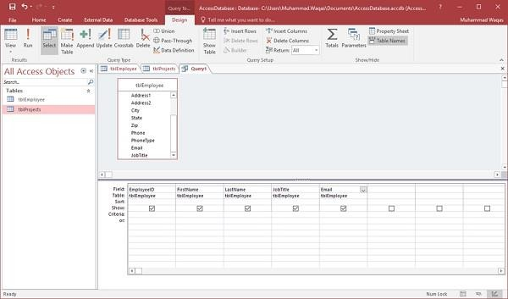
Now click Run on the Design tab, then click Run.
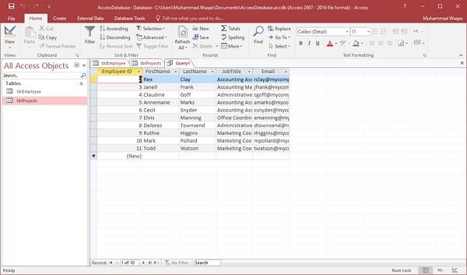
The query runs, and displays only data in those field which is specified in the query.

REPORTS
Reports offer a way to view, format, and summarize the information in your Microsoft Access database. For example, you can create a simple report of phone numbers for all your contacts

Example
We will now take a simple example to understand the process of creating a very simple report. For this, we need to go to the Create tab.
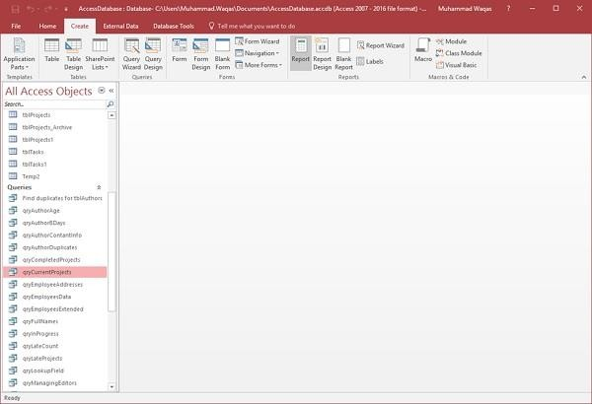
Before clicking on the Report button to create a basic report, make sure the proper query is selected. In this case, qryCurrentProjects is selected in your navigation pane. Now click on the Report button, which will generate a report based on that query.
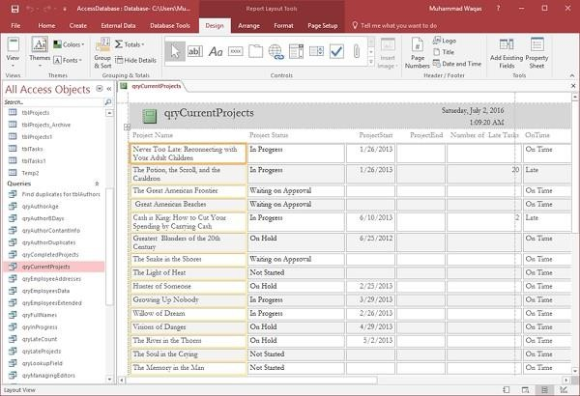
You will see that the report is open in Layout view. This provides a quick way to adjust the size or width of any of your fields that you see on the report. Let us now adjust the column widths to make everything fit in a better way.

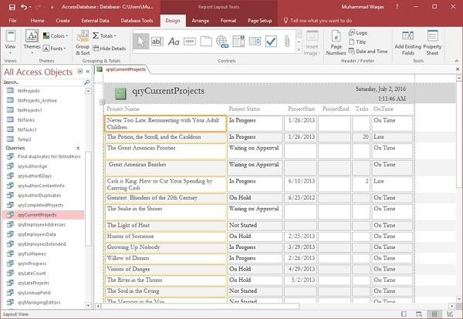
Scroll down and adjust the page control at the bottom.
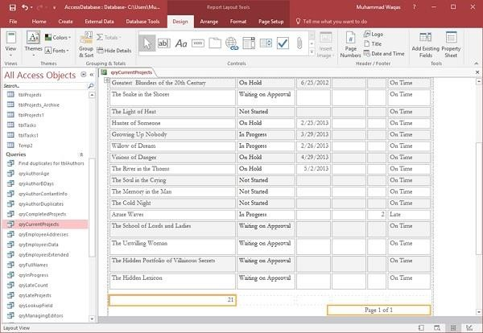
This was a very quick way to create a very simple report. You could also make minor changes and adjustments from the report design view.
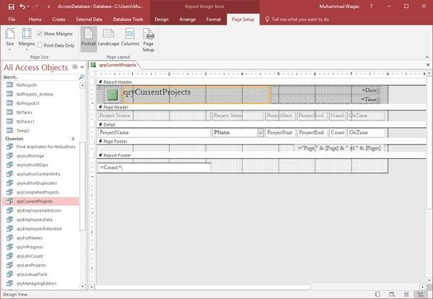

- Just like forms, a report is made up of a variety of different sections.
- You have the detail section, which is where all of your data lives for the most part.
- You also will see a page header and a page footer section; these appear at the top and at the
bottom of every single page in your report.
Let us now change the Title of the report and give it another name.

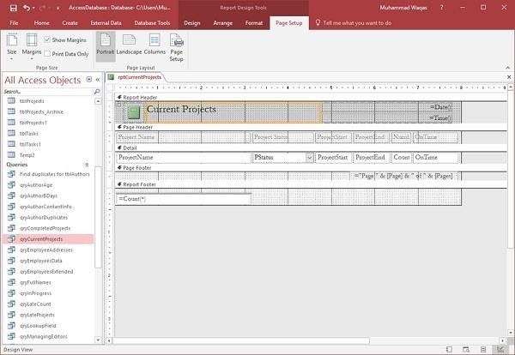
Click on the save icon to save your report.
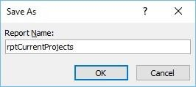
You will get the above dialog box.
Enter a name for your report and click Ok. If you want to view what this report will actually look like, in Print Preview, you can go back to the View button and click on Print Preview to see what this report would look like when printed either on paper or as a PDF.
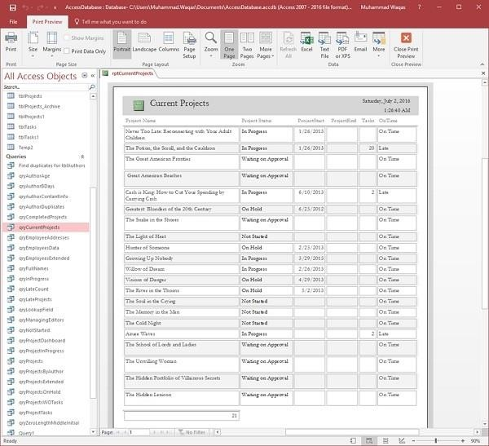

Create a Report Using Report Design
Report Design is another method for creating a quick report in Access. For this, we need to use the Report Design View button, which is like the Form Design button. This will create a blank report and open it directly to the Design View, allowing you to change the control source and add fields directly to the Design View of the report.
Let us now go to the Create tab and click on the Report Design button.
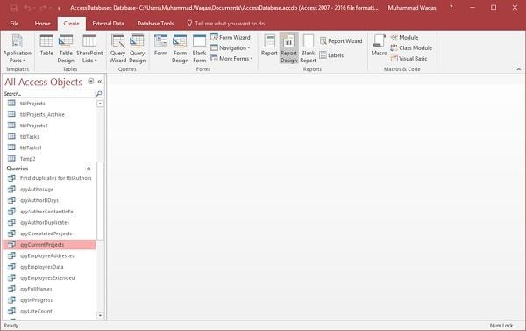
It will open a blank report or an unbound report, meaning this report is connected to no other object in our database.
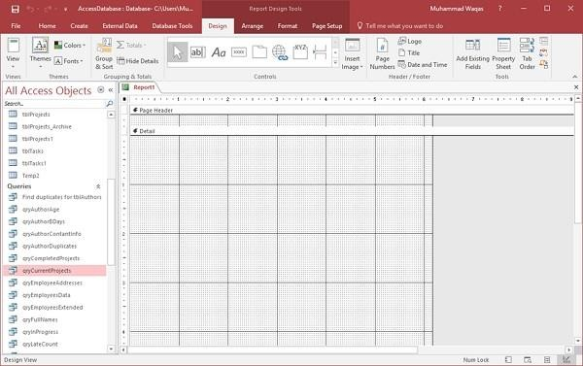
On the Design tab in the Tools group, select the Property Sheet. This will open up the Property pane.
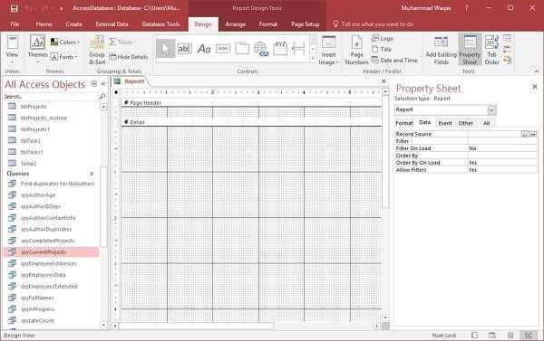

On the Data tab, assign a record source to this report, to connect it to a database object as in the following screenshot.
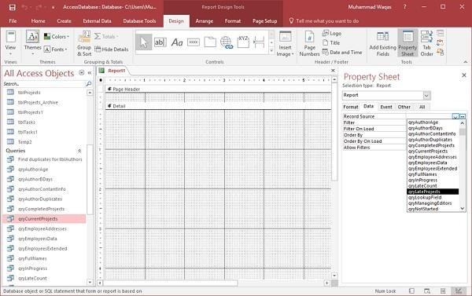
Select qryLateProjects from the drop-down and now, the next step is to go through and add some fields to this report by clicking on Add Existing Fields list button on the Design tab.
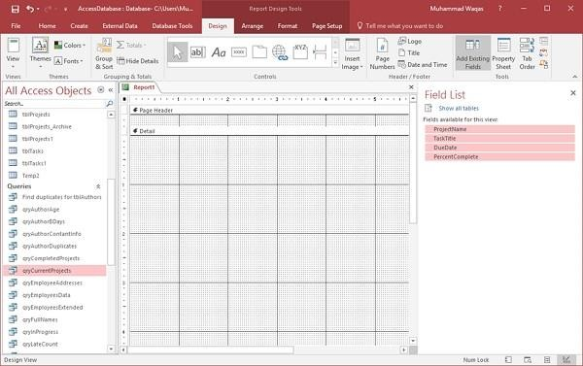
Select the fields as in the above screenshot.
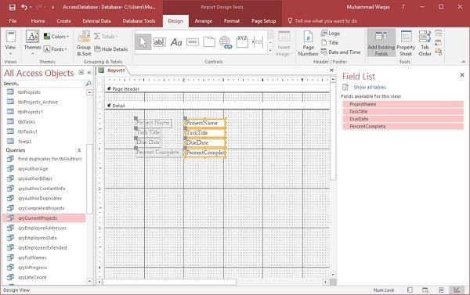
Drag the fields to you report as in the above screenshot. Go the Arrange tab, and in the Table group, you have a couple of options to choose from.

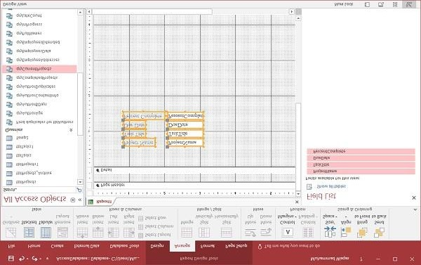
There is a stacked layout and a tabular layout, which is a layout that is very similar to a spreadsheet. Let us select the tabular layout.
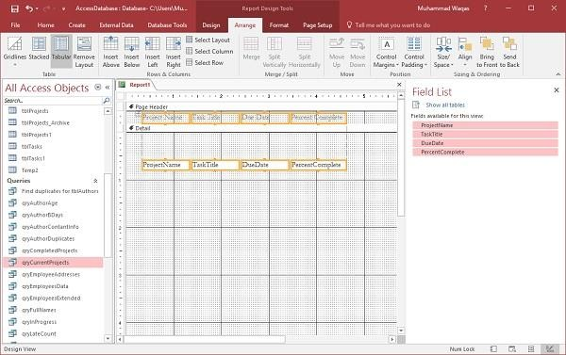
You can see that it moves all of the labels up to the page header area. These labels will appear only once at the top of every page and the data query will repeat for every record in the Details section. Now, you can go through and make some adjustments to make your ProjectName field wider.

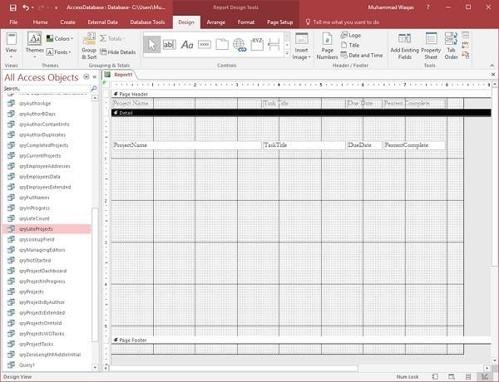
As you can see in the above screenshot, there is a lot of space between Detail section and Page Footer.
Let us drag the Page Footer up to reduce the space as in the following screenshot. We will now go to the Design tab and click on the View button and choose Report View.
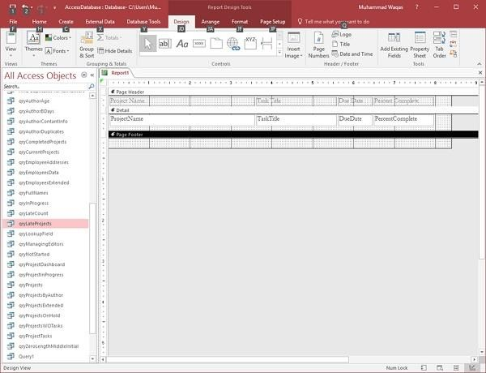

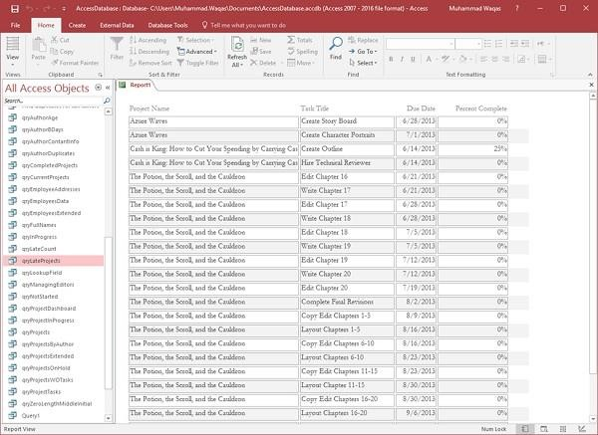
You can now see that some project names are not complete; you can adjust this with either the design view, or you can use the layout view to do that.
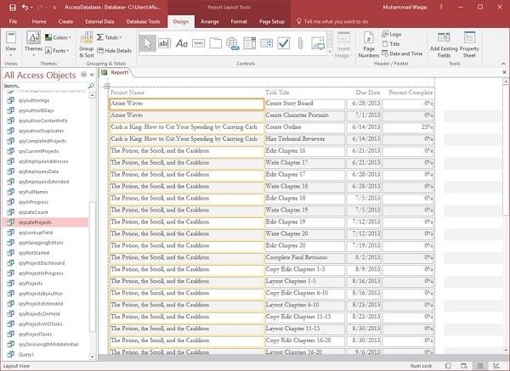
That is how we create a simple report just from the Design View.

